The physicochemical properties of the WP_407215218.1 protein estimated by ProtParam
Descriptions | Value
No. of amino acids | 388
Molecular weight | 42070.12
Theoretical PI | 6.56
No. of positively charged residues | 39
No. of negatively charged residues | 41
No. of atoms | 5901
Instability Index | 43.23
Aliphatic Index | 90.34
Grand average of hydropathicity | -0.070

The subcellular localization prediction of the query protein WP_407215218.1
Sever | Prediction
CELLO v.2.5 | Cytoplasmic localization
Protb | Cytoplasmic localization

Result of CDD of WP_407215218.1
Name | Accession | Description | Interval | E-value
lldD | PRK11197 | L-lactate dehydrogenase | 1-375 | 0

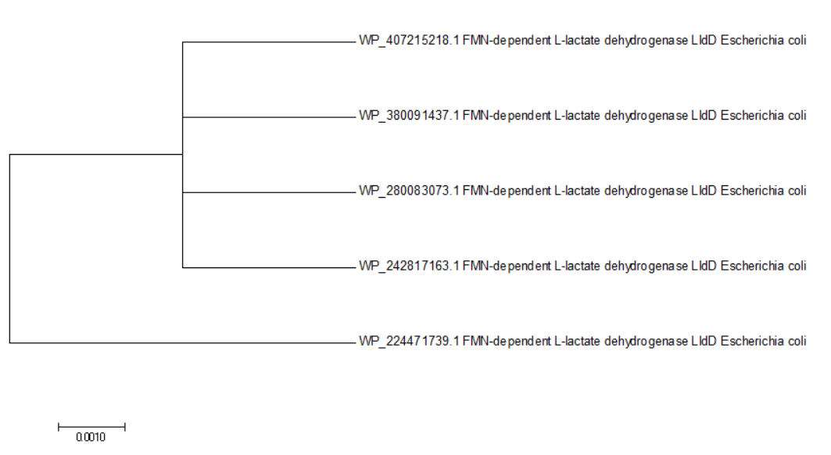
Phylogenetic tree with true distance from target protein (WP_407215218.1). The tree was generated using Mega 7 software. Here, the scale bar estimates sequence divergence, and amount of genetic change is represented by the line segment with the number (0.0010)
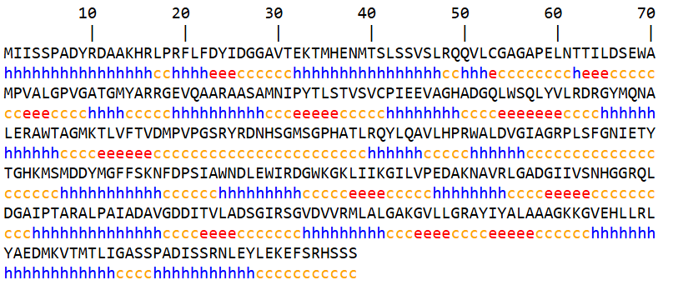
Secondary structure prediction and analysis
SOPMA server was used to estimate the proportions of extended strand (12.89%), alpha helix (43.04%), and random coil (44.07%)

